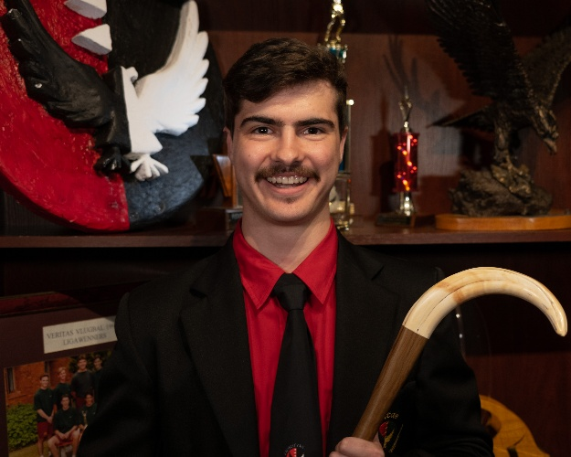***Stephen Nel***

**076 842 0814**  **stephennel321@gmail.com**

**PO Box 123; Komatipoort; 1340**

**1. PERSONAL INFORMATION**

**Surname :** Nel

**Full Names :** Stephen

**I.D.-number :** 020313 5057 081

**Nationality**  **:** South-African

**Languages**  **:**  Afrikaans and English

**LinkedIn :** <http://www.linkedin.com/in/stephen-nel-976962342>

**GitHub :** <https://github.com/StephenNel>

**Virtual CV :** <https://stephennel.github.io/Virtual-CV/>

**2. CAREER GOAL/OBJECTIVE**

I am a dedicated and goal-oriented finale year BSc Information Technology student at North-West University, driven by a passion for innovation and a desire to make a positive impact through technology. Throughout my academic career, I have demonstrated a consistent commitment to excellence, earning multiple academic awards, leadership positions, and recognition for my contributions to both school and community life.

My ambition is to become a skilled software engineer who not only delivers high-quality solutions but also contributes meaningfully to the world. I value companies that prioritize sustainability, social development, and ethical decision-making alongside business success. I thrive in challenging environments and am excited by opportunities that require creativity, resilience, and continuous growth.

**3. Skills**

• **Programming Languages:** Python, Java, C++, C#, HTML/CSS, Assemble, **SQL, MATLAB**

• **Software & Tools:** Visual Studio, Git/GitHub, Unity, Oracle, MATLAB, PyCharm, MPLAB, CodeBlocks

• **Problem Solving:** Strong analytical and logical reasoning developed through engineering modules

• **Communication:** Excellent written and verbal communication in both Afrikaans and English

• **Teamwork:** Proven ability to work collaboratively in group projects and leadership roles

• **Adaptability:** Quick to learn new technologies and adjust to different working environments

**4. LIFE EXPERIENCE**

**4.1 CULTURE** – Formed part of the Skouspel 2020 Revue Group for Hoërskool Nelspruit.

2024 I helped out at the first years concert at Veritas Men’s Residence.

**4.2 SPORT** – I played in the following sport teams during my secondary school career.

|  |  |  |  |
| --- | --- | --- | --- |
| Year | Sport | Team | Comment |
| 2016 | Hockey | u/14 |  |
|  | Cricket | u/14 |  |
| 2017 | Rugby | u/15 |  |
|  | Cricket | u/15 |  |
| 2018 | Rugby | u/16 |  |
|  | Cricket | 3rd Team |  |
| 2019 | Hockey | 2nd Team |  |
|  | Cricket | 3rd Team |  |
| 2020 | Hockey | 2nd Team | Team Captain |
| 2022 | Table tennis | Number 2 |  |
| 2023 | Table tennis | Number 1 |  |
| 2024 | Table tennis | Number 1 |  |
| 2025 | Table tennis | Number 2 |  |

**4.3 LEADERSHIP**– I believe in leading from the front, being an example to my fellow students and to return the investment that an academic institution makes in you as an individual. I have been part of school management in the last three years.

|  |  |
| --- | --- |
| Year | Achievement |
| 2018 | Member of Student Council |
| 2019 | Member of Student Council |
| 2020 | Member of School Management Committee |
|  | Academic Guardian: Grade 8 (Hostel) |
| 2022/2023 | House committee member at NWU Veritas Men’s Residence.  Portfolios: Media and Communication and Archives |
| 2024 | Chairperson for the Media and Communication at Veritas. |

**4.4 ACADEMIC ACTIVITIES**

|  |  |
| --- | --- |
| Year | Achievement |
| 2016 | Academic Award |
| 2017 | Academic Award |
| 2018 | Academic Award |
|  | Science Expo 82% |
| 2019 | Academic Award |
| 2020 | Academic Guardian: Grade 8 (Hostel) |

**4.5 COMMUNITY & SCHOOL ACTIVITIES**– I believe a person should be well balanced in life and should partake in as many activities that are possible. My academic achievements are my highest priority, but involvement in sport and other school and cultural activities are just as important.

Outreach to previously disadvantaged community schools and old age homes formed part of the activities attended to by the school management committee.

|  |  |
| --- | --- |
| Year | Achievement |
| 2017 | Certificate for Involvement |
| 2018 | Certificate Service Delivery |
| 2019 | Certificate Service Delivery |
| 2020 | Skouspel 2020 Revue Group |
| 2021/22/23 | RAG for Veritas |
| 2022/23/24 | Open day for Veritas |

**4.6 INTEREST AND HOBBIES** - Photography; Computer Games, Information Gathering (Internet research) and physical activities (Sport, muscle building etc).

**5. WORK EXPERIENCE**

|  |
| --- |
| 2018: Alfred Dunhill Cup Golf Tournament @ Leopard Creek Malalane. General assistant. (December 2018) |
| 2019: Alfred Dunhill Cup Golf Tournament @ Leopard Creek Malalane. General Sound Assistant, including setup and breakdown of infrastructure. (December 2019) |
| 2022/23 House committee member at NWU Veritas Men’s Residence.  Portfolios: Media and Communication and Archives |
| 2024: Alfred Dunhill Cup Golf Tournament @ Leopard Creek Malalane. Waiter in the Clubhouse (December 2024) |

**6. ADENDUMS**

**6.1** National Senior Certificate

**6.2** Academic Record – 2023/24 – North-West University

**7. REFERENCES**

**Lecturer** Mr Wouter de Vos, Department Head: Physical Sciences, Hoërskool Nelspruit,

013 755 2082.

Mr Pieter Jordaan, Lecturer Information Technology, Hoërskool Nelspruit,

013 755 2082.

Mr Johan Hatting, Headmaster (RET), Hoërskool Nelspruit, 013 755 2082.